***Remember to use Present Simple talking about permanent situations, habits and regular actions.***

*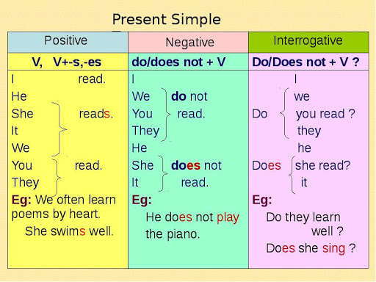***Present Simple**

We use the Present Simple tense to talk about:

* things that happen regularly;
* permanent situations;
* habits and routines;
* laws of nature;
* timetables and programmes.