Establishing Modern Master-level Studies in Information Systems
561592-EPP-1-2015-1- FR-EPPKA2-CBHE-JP

WP4
Teaching Methods for course
“Information System Development and Deployment”

by Kovaliuk T. (Igor Sikorsky KPI)

2017

Active methods of teaching by types of training

To imitative gaming lessons are: business game, role-playing, game design, game lessons on machine models.
Business game (BG) is an imitation simulation of the processes of managing socio-economic systems and people's professional activity in conditional situations with the purpose of studying and solving problems that have arisen.

Mandatory signs of BG:

• the presence of the problem of managing the socio-economic or socio-psychological system;
• the existence of common goals for the entire team;
• the presence of different roles and, in accordance with them, the difference of interests (conflict) of the participants assigned to perform these roles;
• impossibility of complete formalization of the system, uncertainty in the situation, consideration of the probabilistic nature of many factors and, on the basis of this, the existence of a game simulation model of the process under consideration;
• availability of a real or conditional time factor;
• the dynamics of the change in the situation and the presence of feedback, depending on the decisions of the participants in the game at previous points in time and affecting the change in the situation to the next, ie, the presence of a "chain of decisions";
• availability of a system for evaluating the results of gaming activities;
• the presence of a system of motivation of participants, which provides an objective assessment of the personal contribution of each participant in the game in achieving the goal of the goal, the overall result of the activity of the team;
• multi-alternative solutions;
• mandatory minimum required and sufficient documentary support for a business game;
• presence of a controlled emotional stress.

The purpose of BG
"Contour" business game can be applied taking into account the specifics of different spheres of professional activity at different levels of training, while filling the "contour" (game model) with the volume and degree of complexity of problems that is available to the level of preparedness of trainees.
Organizational-activity games (OAG) are aimed at imitating the processes of solving new problems, complex social and production tasks that require not only the unification of efforts of specialists of different directions and their interest in achieving the desired result, but also the implementation of technological procedures in order to free participants from standards and templates thought activity and behavior.
Innovative games are designed to develop and form innovative thinking and behavior.
Search and approbation games are designed to develop intellectual and creative potential.
Gaming sessions on machine models assume the implementation of gaming learning methods using computer models.
Imitative non-player types of training include situational methods (case studies), simulation exercises, group and individual training.
Non-cimulation types of training include: problem lectures and seminars, thematic discussions, brainstorming, group consultation, pedagogical game exercises, MASTAC technology (the method of active sociological testing, analysis and control), presentation, Olympiad, scientific and practical conferences.

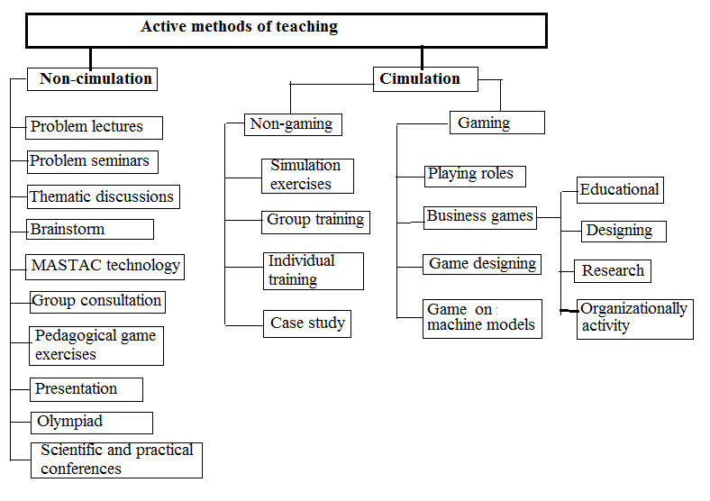
Figure 1. Classification active methods of teaching

Selection of teaching methods
# | Learning objectives | Teaching methods
 | Convince the need for training. Identify the needs of knowledge, clarify the program. | Input control of knowledge using tools and methods of programmed training
 | Raise interest in the subject. Destroy stereotypes. To encourage creative thinking and the formation of productive knowledge | Brainstorm. attacks, relay, MASTAK
 | Remove questions, identify and eliminate misconceptions and incorrect practical application of the materials studied | Group consultations, Programmatic consultations. Individual consultations
 | To complete and deepen the received knowledge, to form or improve the skills and their application | Analysis of situations, examination of material, role-playing, training. business games, etc.
 | Create conditions for an active exchange of knowledge and experience, creative development of best practices | Thematic discussion, round table, master class, training
 | Create conditions for the practical application of knowledge and skills | Solving situational problems and conducting business games on a specific material

Stages of development of a business game

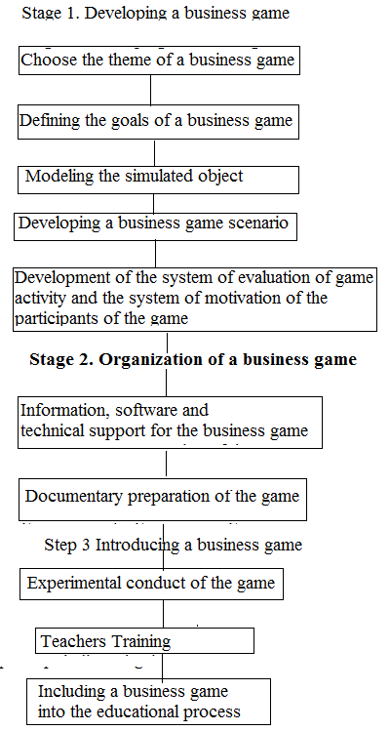
Figure 3. Stages of development of a business game

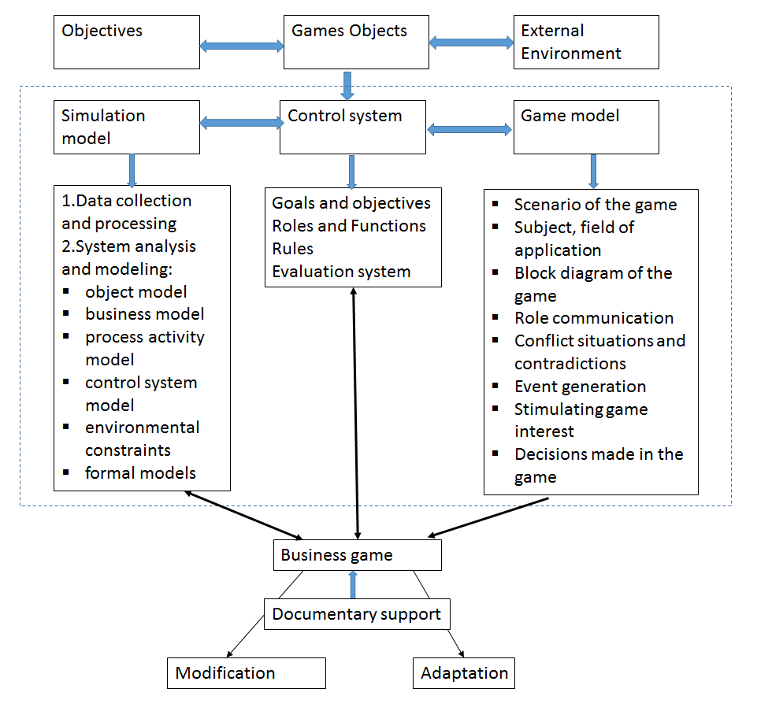
Figure 4. Block diagram of a business game

Business game design
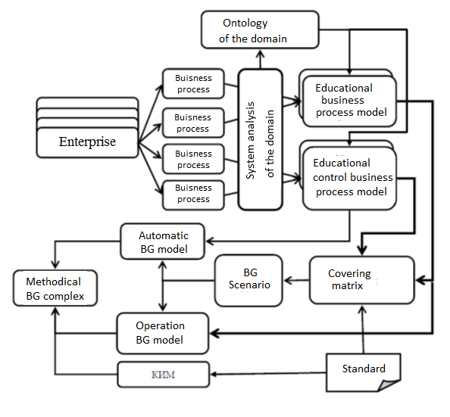
Figure 5. Business game design

Teaching Techniques
Education, like almost every other area of our society, has evolved in leaps and bounds in recent years. Traditional teaching techniques, based mainly on a teacher explaining a topic and students taking notes, may still be useful on occasion, but education today revolves more around encouraging the student to awaken their curiosity and desire to learn.
A number of different teaching techniques have emerged due to this change in education. Many of these teaching techniques are not actually new however! The use of technology in the classroom has simply given education a new lease of life allowing us to approach old ideas in new ways.
Outlined below are some popular teaching techniques that have arisen from the integration of technology in education.

Flipped Classroom (Inverting your class):
The Flipped Classroom Model basically involves encouraging students to prepare for the lesson before class. Thus, the class becomes a dynamic environment in which students elaborate on what they have already studied. Students prepare a topic at home so that the class the next day can be devoted to answering any questions they have about the topic. This allows students to go beyond their normal boundaries and explore their natural curiosity.
GoConqr’s free online learning tools can be integrated into the Flipped Classroom teaching model. Using GoConqr, you can easily share resources with a group, in this case a class, allowing students to study these resources from home and prepare for the next class.

2. Design Thinking (Case Method)
This technique is based on resolving real-life cases through group analysis, brainstorming, innovation and creative ideas. Although “Design Thinking” is a structured method, in practice it can be quite messy as some cases may have no possible solution.
However, the Case Method prepares students for the real world and arouses their curiosity, analytical skills and creativity. This technique is often used in popular MBA or Masters classes to analyze real cases experienced by companies in the past.

3. Self-learning
Curiosity is the main driver of learning. As a basic principle of learning, it makes little sense to force students to memorize large reams of text that they will either begrudgingly recall or instantly forget. The key is to let students focus on exploring an area which interests them and learn about it for themselves.
A common technique for exploring self-learning is the use of Mind Maps. Teachers can create a central node on a Mind Map and allow students the freedom to expand and develop ideas. For example, if the focus is the Human Body, some students may create Mind Maps on the organs, Bones or Diseases that affect the human body. Later the students would be evaluated according to the Mind Maps they have created and could collaborate with each other to improve each others Mind Maps and come to a more comprehensive understanding of the Human Body.

4. Gamification
Learning through the use of games is one of the teaching methods that has already been explored especially in elementary and preschool education. By using games, students learn without even realizing. Therefore, learning through play or ‘Gamification‘ is a learning technique that can be very effective at any age. It is also a very useful technique to keep students motivated.
The teacher should design projects that are appropriate for their students, taking into account their age and knowledge, while making them attractive enough to provide extra motivation. One idea may be to encourage students to create quizzes online on a certain topic. Students can challenge their peers to test themselves and see who gets a higher score. In this way, students can enjoy the competition with peers while also having fun and learning.

5. Social Media
A variant of the previous section is to utilize social media in the classroom. Students today are always connected to their social network and so will need little motivation to get them engaged with social media in the classroom. The ways you can use teaching methods are quite varied as there are hundreds of social networks and possibilities.
A good example is the initiative carried out by the Brazilian Academy of Languages “Red Ballon”, which encouraged students to review the tweets of their favorite artists and correct grammatical errors that they committed in an effort to improve their English language skills!

6. Free Online Learning Tools
There is an array of free online learning tools available which teachers can use to encourage engagement, participation and a sense of fun into the classroom. Teachers can create an interactive and dynamic classroom environment using, for example, online quizzes to test student’s knowledge.
If you haven’t used GoConqr’s free online learning tools yet, sign up now to create Mind Maps, Flashcards, Quizzes, Course and even Flowcharts. Encourage your students to sign up to GoConqr too so that you can create a Group and invite each of your students to become a member. This means you can share study resources directly with each student online and even apply the Flipped Classroom Model to your teaching methods.

References
- Teaching Techniques You Should Know! Electronic resourse. Access mode: https://www.goconqr.com/en/examtime/blog/teaching-techniques/
- Teaching Methods and Organisation. Electronic resourse. Access mode: https://www.sess.ie/resources/teaching-methods-and-organisation

