Topic 3. Objectives and principles of EAM
3.1.The need of EAM
3.2. Enterprise architecture models
3.3. Objectives and methodology
The need of EAM
Enterprise architecture (EA) is the practice of conducting enterprise analysis, design, planning, and implementation using a holistic approach for the successful development and execution of strategy. EA applies architecture principles and practices to guide organizations through the business, information, process, and technology changes necessary to execute their organization’s strategies.
Like many other disciplines, EA is evolving. [1] The EA concept dates back to the late 1980s as a response to the increased complexity associated with the introduction of distributed computing. For the first time, the unmanaged and uncontrolled replication of systems providing similar capabilities, as well as the same or very similar data sets were springing up around the enterprise. The result was increased difficulty in integrating and evolving systems to address changing business needs. The initial EA concept was to adopt an enterprise-wideview of an organization’s computing resources. By developing and applying standards and governance throughout the organization, unnecessary complexity and redundancy could be avoided.
EA provides this enterprise-wide view. Although it was initially motivated by the need to control EIT expense, EA is now also driven by the need for improved IT innovation, effectiveness, and efficiency in a rapidly changing business and technology environment. If done well, an organization’s enterprise architecture provides context for all the enterprise’s IT activities.
The results of the EA process provides inputs to the enterprise's strategy at the highest level. EA also takes the enterprise's strategy and figures how to manifest it throughout the organization, both high and low. <p>While there are a number of frameworks, practices, and approaches for EA, there is a generally accepted body of conventional wisdom on the subject. This chapter introduces the basic concepts and the most common practices.

Goals and Principles
The goals of the Enterprise Architecture effort in an organization should be:
- Help the enterprise understand its current operations.
A major function of EA is revealing and documenting the relationships between business elements, information elements, and the underlying information technology and technology infrastructure. By demonstrating these interrelationships from a systems level down to the most detailed element or artifact level, EA provides the information needed to connect an organization’s conceptual business strategy to the execution of that strategy.
- Guide the organization to the desired future (“To Be”) state.
Carefully understand the enterprises long-term goals and future desired state. Provide holistic information and insights to help executives and IT make better decisions and to identify opportunities to implement solutions that will enable the organization to reach the future desired state.
- Align IT with the enterprise’s business.
In the best of all worlds, EA can create a bridge between the needs of the organization and the support provided by EIT. EIT/business alignment has become an increasingly widespread goal for EA, and has become the dominant value proposition for EA. Alignment activities, such as the mapping of business roles and processes to information data flows and the underlying EIT systems and technology that support them, creates this alignment.
- Help manage the complexity of the business, of IT, and the relationship between the two.
The elimination of unnecessary complexity was the earliest justification for EA. Eliminating complexity makes EIT solutions easier to understand, easier to control, and, therefore, less expensive to develop, operate, and maintain. An EA-based framework and roadmap provide a means to eliminate redundancy as well as the integration of systems and data.
- Facilitate organizational change, transformation, and agility.
In a business and technology environment of continuous and rapid change, organizations that can anticipate and respond appropriately and quickly are more likely to survive. Robust EA processes, such as providing artifacts (requirements, specifications, guiding principles, and conceptual models) that describe the desired future state of enterprise and the path to get there can enable rapid change.
The principles of Enterprise Architecture include:
- Architectural decisions seek to simplify operations.
- Decision are based on long-term strategy, even at the expense of short-term profitability.
- Think globally, act locally. Architectural decisions for solutions consider the impact on the entire enterprise.
- Business goals are specific, measurable, attainable, relevant, and timely.
- The definition of the desired future state and the path to get there are re-evaluated often.
- Processes and changes should promote collaboration between the business and IT.
- The effectiveness of the architecture and the adherence to the architecture must be demonstrable and measurable.
- Models are only useful when they are accurate and kept current.

Context Diagram
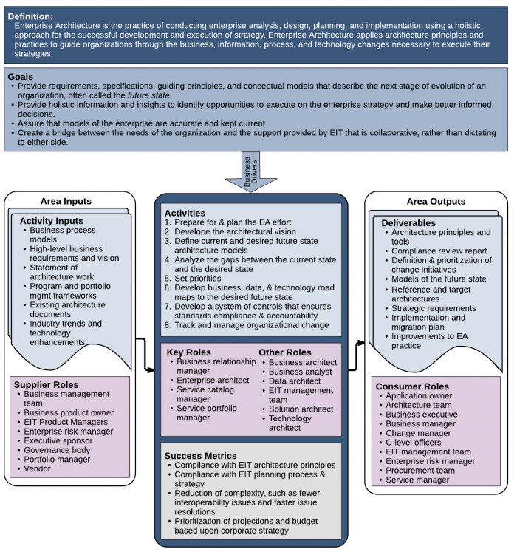
Figure 1. Context Diagram for Enterprise Architecture

What is Enterprise Architecture?
The first definition listed in a dictionary for enterprise is generally some variation on the concept of an ambitious endeavor or undertaking. Subsequent definitions define it as the entity (typically an organization) that carries out such an undertaking. This latter definition is the common understanding of the meaning of enterprise within the EA community. More specifically, the term enterprise was adopted to label not just commercial undertakings, but also such organizations as governments and nonprofits within its compass.
The formal definition of architecture cited most frequently by the EA community is the definition from ISO/IEC/IEEE 42010:2011:
“... “architecture” means whatever the EA framework being used (explicitly or implicitly) implies it is by the various architectural representations it recommends for use. ” [2]
The Federation for Enterprise Architecture Professional Organizations (FEAPO) defines enterprise architecture as:
“Enterprise architecture is a well-defined practice for conducting enterprise analysis, design, planning, and implementation, using a holistic approach at all times, for the successful development and execution of strategy. Enterprise architecture applies architecture principles and practices to guide organizations through the business, information, process, and technology changes necessary to execute their strategies. These practices utilize the various aspects of an enterprise to identify, motivate, and achieve these changes.” [3]
Analogies between enterprise architecture and urban planning have been made, because both define common guidelines, standards, and frameworks with which solution architects and building architects, respectively, must comply (see Figure 2).
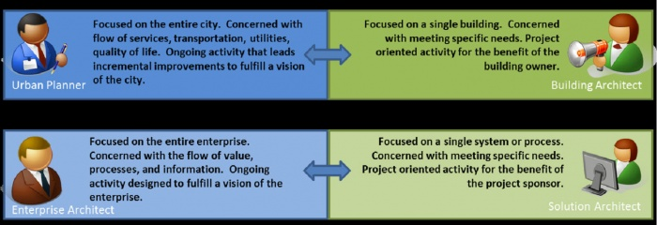
Figure 2. Urban Planner and Enterprise Architect versus Building Architect and Solution Architect [3]

Enterprise architecture models
Enterprise architecture framework
An enterprise architecture framework (EA framework) defines how to create and use an enterprise architecture. An architecture framework provides principles and practices for creating and using the architecture description of a system. It structures architects' thinking by dividing the architecture description into domains, layers, or views, and offers models - typically matrices and diagrams - for documenting each view. This allows for making systemic design decisions on all the components of the system and making long-term decisions around new design requirements, sustainability, and support.
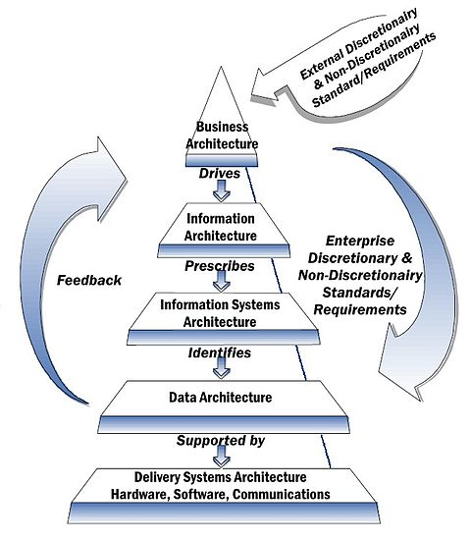
NIST Enterprise Architecture Model initiated in 1989, one of the earliest frameworks for enterprise architecture.

Enterprise architecture regards the enterprise as a large and complex system or system of systems. To manage the scale and complexity of this system, an architectural framework provides tools and approaches that help architects abstract from the level of detail at which builders work, to bring enterprise design tasks into focus and produce valuable architecture description documentation.
The components of an architecture framework provide structured guidance that is divided into three main areas:
- Descriptions of architecture: how to document the enterprise as a system, from several viewpoints. Each view describes one slice of the architecture; it includes those entities and relationships that address particular concerns of interest to particular stakeholders; it may take the form of a list, a table, a diagram, or a higher level of composite of such.
- Methods for designing architecture: processes that architects follow. Usually, an overarching enterprise architecture process, composed of phases, broken into lower-level processes composed of finer grained activities. A process is defined by its objectives, inputs, phases (steps or activities) and outputs. It may be supported by approaches, techniques, tools, principles, rules, and practices.
- Organization of architects: guidance on the team structure and the governance of the team, including the skills, experience, and training needed.
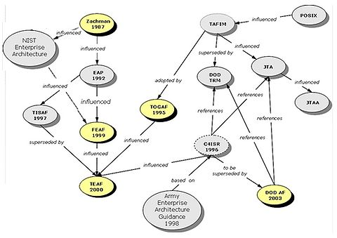
Overview of Enterprise Architecture Frameworks evolution (1987–2003). On the left: The Zachman Framework 1987, NIST Enterprise Architecture 1989, EAP 1992, TISAF 1997, FEAF 1999 and TEAF 2000. On the right: TAFIM influenced by POSIX, JTA, JTAA, TOGAF 1995, DoD TRM and C4ISR 1996, and DoDAF 2003.
EA framework topics
Architecture and building governance
People who remodel a home are aware that the architect produces detailed drawings that specify plumbing, electrical, and building construction information for the entire structure. The architect responsible for the design produces (or oversees others who produce) blueprints for each phase of the project—from structural changes to size and layout of rooms. Moreover, to successfully complete the project, the architect operates within a framework of building codes. City or county inspections ensure the work complies with building codes.
Enterprise architecture works in a similar manner. An architecture description document can be thought of as the blueprint for the procurement and realization of a system. But an enterprise architecture includes more than just an abstract description of the system's structure and behavior. It includes also principles, policies and standards (akin to building codes) that ensure that systems are soundly constructed. Governance of the enterprise architecture and of its implementation requires organization and processes (akin to city and county inspectors and the processes for checking building improvement projects).
Architecture domain
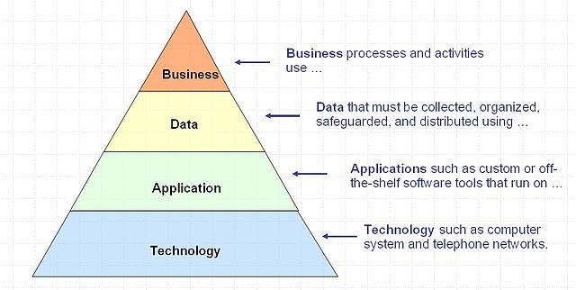
Layers of the enterprise architecture.
Since Stephen Spewak's Enterprise Architecture Planning (EAP) in 1993, and perhaps before then, it has been normal to divide enterprises architecture into four architecture domains.
- Business architecture,
- Data architecture,
- Applications architecture,
- Technology architecture.
Note that the applications architecture is about the choice of and relationships between applications in the enterprise's application portfolio, not about the internal architecture of a single application (which is often called application architecture).
Many EA frameworks combine data and application domains into a single (digitized) information system layer, sitting below the business (usually a human activity system) and above the technology (the platform IT infrastructure).
Layers of the enterprise architecture
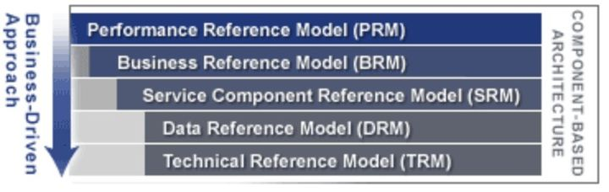
Example of the federal enterprise architecture, which has defined five architectural layers.
For many years, it has been common to regard the architecture domains as layers, with the idea that each layer contains components that execute processes and offer services to the layer above. This way of looking at the architecture domains was evident in TOGAF v1 (1996), which encapsulated the technology component layer behind the platform services defined in the "Technical Reference Model" - very much according to the philosophy of TAFIM and POSIX.
The view of architecture domains as layers can be presented thus:
- Environment (the external entities and activities monitored, supported or directed by the business).
- Business Layer (business functions offering services to each other and to external entities).
- Data Layer (Business information and other valuable stored data)
- Information System Layer (business applications offering information services to each other and to business functions)
- Technology Layer (generic hardware, network and platform applications offering platform services to each other and to business applications).
Each layer delegates work to the layer below. In each layer, the components, the processes and the services can be defined at a coarse-grained level and decomposed into finer-grained components, processes and services. The graphic shows a variation on this theme.
Components of enterprise architecture framework
In addition to three major framework components discussed above.
- Description advice: some kind of Architecture Artifacts Map or Viewpoint Library
- Process advice: some kind of Architecture Development Method, with supporting guidance.
- Organization advice: including an EA Governance Model
An Ideal EA Framework should feature:
- Business Value Measurement Metrics
- EA Initiative Model
- EA Maturity Model
- Enterprise Communication Model
Most modern EA Frameworks (e.g. TOGAF, ASSIMPLER, EAF) include most of the above. Zachman has always focused on architecture description advice.
Enterprise architecture domains and subdomains
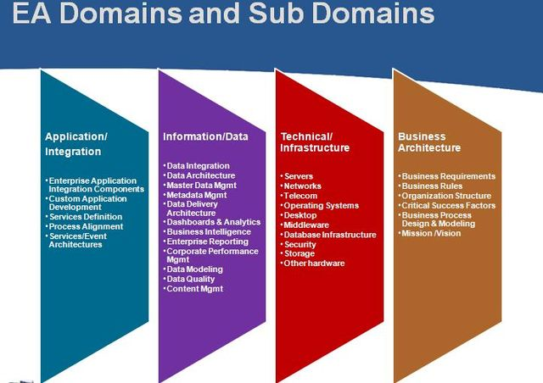
Enterprise architecture reference architecture with sub domains
The application and technology domains (not to be confused with business domains) are characterized by domain capabilities and domain services. The capabilities are supported by the services. The application services are also referred to in service-oriented architecture (SOA). The technical services are typically supported by software products.
The data view starts with the data classes which can be decomposed into data subjects which can be further decomposed into data entities. The basic data model type which is most commonly used is called merda (master entity relationship diagrams assessment, see entity-relationship model). The Class, subject and entity forms a hierarchical view of data. Enterprises may have millions of instances of data entities.
The Enterprise Architecture Reference Traditional Model offers clear distinction between the architecture domains (business, information/data, application/integration and technical/infrastructure). These domains can be further divided into Sub domain disciplines. An example of the EA domain and sub domains is in the image on the right.
Many enterprise architecture teams consist of Individuals with Skills aligned with the Enterprise Architecture Domains and sub-domain disciplines. Here are some examples: enterprise business architect, enterprise documentational architect, enterprise application architect, enterprise infrastructure architect, enterprise information architect, etc.
An example of the list of reference architecture patterns in the application and information architecture domains are available at Architectural pattern (computer science).
View model
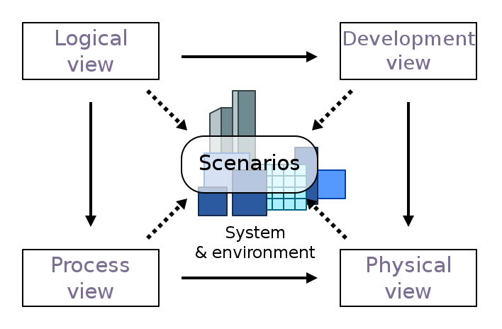
Illustration of the 4+1 view model of architecture.
A view model is a framework that defines the set of views or approaches used in systems analysis, systems design, or the construction of an enterprise architecture.
Since the early 1990s there have been a number of efforts to define standard approaches for describing and analyzing system architectures. Many of the recent Enterprise Architecture frameworks have some kind of set of views defined, but these sets are not always called view models.
Standardization
Perhaps the best-known standard in the field of software architecture and system architecture started life as IEEE 1471, an IEEE Standard for describing the architecture of a software-intensive system approved in 2000.
In its latest version, the standard is published as ISO/IEC/IEEE 42010:2011. The standard defines an architecture framework as conventions, principles and practices for the description of architectures established within a specific domain of application and/or community of stakeholders, and proposes an architecture framework is specified by:
- the relevant stakeholders in the domain,
- the types of concerns arising in that domain,
- architecture viewpoints framing those concerns and
- correspondence rules integrating those viewpoints cited before.
Architecture frameworks conforming to the standard can include additional methods, tools, definitions, and practices beyond those specified.

References
[1] L. Fehskens, “Why We Can’t Agree on What “Enterprise Architecture” Means, and Why That’s OK, At Least for Now,” Enterprise Architecture Conference Europe, London June 2013.
[2] ISO/IEC/IEEE, “ISO/IEC/IEEE 42010:2011, Systems and software engineering — Architecture description,” http://www.iso.org/iso/catalogue_detail.htm?csnumber=50508
[3] Federation of EA Professional Organizations (FEAPO), “Common Perspectives on Enterprise Architecture,” Architecture and Governance Magazine, Issue 9-4, November 2013, pp.11-17.
[4] M. Porter, “The Five Competitive Forces that Shape Strategy,” Harvard Business Review, January 2008, pp. 79-83.
[5] J. Lapalme, “Three Schools of Thought on Enterprise Architecture,” IT Professional, vol.14, no. 6, pp. 37-43, Nov.-Dec. 2012, doi:10.1109/MITP.2011.109.
[6] N. Malik, “Three Schools of Thought for Enterprise Architecture,” blog, 28 May 2012; http://blogs.msdn.com/b/nickmalik/archive/2012/05/28/three-schools-of-thought-for-enterprise-architecture.aspx
[7] J. Zachman, “A Framework for Information Systems Architecture,” IBM Systems Journal, vol 26, no 3, 1987, IBM Publication G321-5298.
[8] The Open Group (January 23, 2015),“A Historical Look at Enterprise Architecture with John Zachman” http://blog.opengroup.org/2015/01/23/a-historical-look-at-enterprise-architecture-with-john-zachman/
[9] The Open Group (2011),“TOGAF 9.1, Part 11: Architecture Development Method (ADM) — Preliminary Phase” http://pubs.opengroup.org/architecture/togaf9-doc/arch/chap05.html
[10] Enterprise Architecture Framework, Wikipedia, http://en.wikipedia.org/wiki/Enterprise_architecture_framework
[11] This image is copyright John A. Zachman and Zachman International®, Inc. Published with the permission of John A. Zachman and Zachman International®, Inc., www.zachman.com
[12] J. van’t Wout et al, “The Integrated Architecture Framework Explained,” Springer-Verlag, 2010.

