ENTERPRISE ARCHITECTURE DEVELOPMENT

Enterprise architecture development process

1.Identify the purpose of your architecture
- You can define the purpose of your architecture by asking the following questions:
- What information is important for the architecture?
- How much detail is needed to support analysis and decision making?
- Who will produce or use the architecture?
- What is the expected ROI of the architecture?
- What are the maintenance considerations?

2.Identify your business questions
- What is the impact of retiring an application?
- What is the impact of moving a location?
- What applications are needed to support a business process?
- What is the impact of replacing servers?
- What processes need to be developed to support a new strategy?
3.Identify assumptions and business rules (Implement using BPMN(Business Process Management Notation)).

4.Identify your framework

The details about frameworks can be esteemed in a folder INTERNATIONAL STANDARDS AND METHODOLOGIES:
- Zachman
- Federal Enterprise Architecture
- LEADing Frameworks
- DoDAF

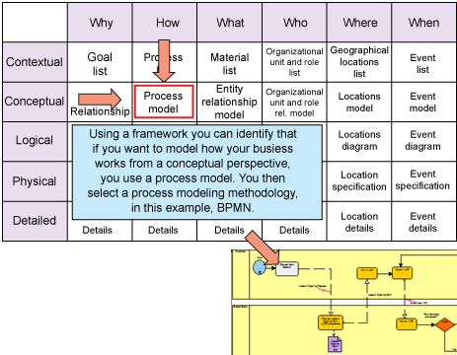

5.Create a metamodel
6.Identify the models needed in the architecture
7.Integrate the architecture

