Management Information System (MIS)

Copyright: Santosh Dhungana

Chapter 1

Managing Digital Firm
As a manager, you will need to know how information systems can make business more competitive, efficient and profitable.

Why Information System?

- It is widely recognized that information system knowledge is essential for managers because most organizations need information system to survive and develop.
- Information system can help company’s extend their reach to far away location’s, offer new products and services, reshape jobs and workflows, and change the way they conduct business.

Why information system?
Why information system matter? How much does IT matter?
Why IT now? Digital convergence and the changing business environment Four powerful worldwide changes had altered the business environment. The first change is emergence and strengthening of the global economy. The second change is transformation of industrial economies and societies information knowledge and information based services economies. The third is the transformation of the business enterprise. The fourth is the emergence of the digital firm.

Emergence of the Global Economy
  - The success of firms today and in future depends on their ability to operate globally.
  - Today information system provides the communication and analytic power that firms need for conducting trade and managing business on a global scale.
  - Globalization and IT also brings new threats to domestic business firm because of global communication and management system, customers now can shop in a worldwide market place, obtaining price and quality information reliably 24hrs a day. To become competitive participants in international markets, firms need powerful information and communication systems.

Transformation of Industrial Economies
  - The US, Japan, Germany and other major industrial power are transformed from industrial economies to knowledge and information based service economies, whereas manufacturing has been moving to low-wage countries.

  - Knowledge and information work new accounts for large percentage of people in developed countries.
  - Knowledge and information are becoming the foundation for mainly new services and products. Knowledge and information intense products such as computer games require a great deal of knowledge to produce.
  - In a Knowledge and information based economy, IT and systems take an great importance knowledge based products and services of great economic value such as credit cards, overnight package delivery and world-wide reservation system are based on new information technology.
  - Information systems are needed to optimize the flow of Knowledge and information within the organization and to help management maximize the firms knowledge resources because employees productivity depends on the quality of the system’s serving them, management’s decisions about IT are critically important to the firm’s prosperity and survival.

Transformation of Business Enterprise
-The traditional business firm was and still is a hierarchical, centralized, structured arrangement of specialist that typically relied on a fixed set of standard operating procedures to deliver a product or services. The new style of business firm is a flattened (less hierarchical), decentralized, flexible arrangements of generalist ho rely on nearly instant information to deliver specific markets or customers.
-The traditional management globe relied and still relies on formal plants, or rigid division of labor and formal rules. The new manager relies on information commitments and networks to establish goals rather than formal planning, a flexible arrangement of teams and individuals working in task forces, and a customer orientation to achieve coordination among employees. The new manager appeals to the knowledge, learning and decision making of individual employees to ensure proper operation of the firm. Information technology makes this type of management possible.

The Emerging Digital Firm
-Intensive use of IT in business firms since mid-1990s’, covered with equally significant organizational re-designed, has created the conditions for a new phenomenon in industrial society- called the fully digital firm. The digital firm can be defined along several dimensions. A digital firm is one where nearly all of the organization’s significant business relationships with customers, suppliers and employees are digitally enabled and mediated. Core business processes are accomplished through digital network spanning entire organization or linking multiple organizations. Business processes refers to the unique manner in which work is organized, coordinated and focused to produce a valuable product or services. Developing a new product, generating and fulfilling an order or hiring an employee are examples of business processes and the way organizations accomplish their business processes can be a source of competitive strength.

In a digital firm any piece of information required to support key business decisions is available at anytime and anywhere in the firm. Digital firms sense and respond to their environment far more rapidly than traditional firms. Digital firms offer extraordinary opportunities for more global organization and management. For managers of digital firms, IT is not simply a useful hand but rather it is the core of business and a primary management tool.
There are four major system that help define the digital firm:
- Supply Chain Management System
- Customer Relationship Management system
- Enterprise System
- Knowledge Management System

These four systems represent the areas where corporations are digitally integrating their information flows and making major information system investment.
A few firms such as Cisco Systems or Dell Computer Corporation are close to becoming fully digital firms using the internet to drive every aspect of their business.

Supply Chain Management System
Information system that automate the relationship between a supplier and customer and its supplies in order to optimize the planning, sourcing, manufacturing and delivery of products and services.

Customer Relationship Management system
Information systems for creating a coherent integrated view of all of the relationships a firm maintains with its customers.

Enterprise System
Integrated enterprises-wide information systems that coordinate key internal processes of the firms, integrated data from manufacturing and distribution finance, sales, and human resource.

Knowledge Management System
System that supports the creation, capture, storage of knowledge in the firm and use by the firm expertise.

An information system contains information about an organization and its surrounding environment. Three basic activities – input, processing, and output produce the information organization needs. Feedback is output returned to appropriate people or activities in the organization to evaluate and refine the input environment factors such as customers, suppliers, competitors, stock holders and regulatory agencies interact with the organization and its information.

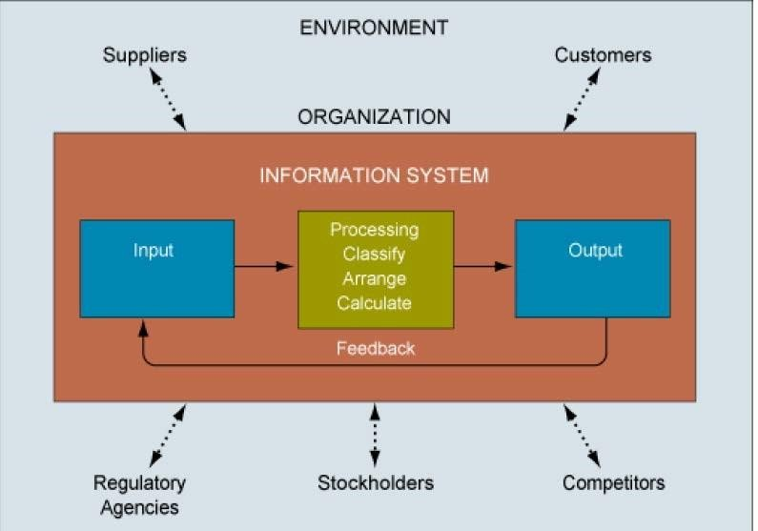
Fig: Function of an Information System

An information system contents information about an organization and its surrounding environment. Three basic activities – input, processing, and output produce the information organization needs. Feedback is output returned to appropriate people or activities in the organization to evaluate and refine the input environment factors such as customers, suppliers, competitors, stock holders and regulatory agencies interact with the organization and its information.

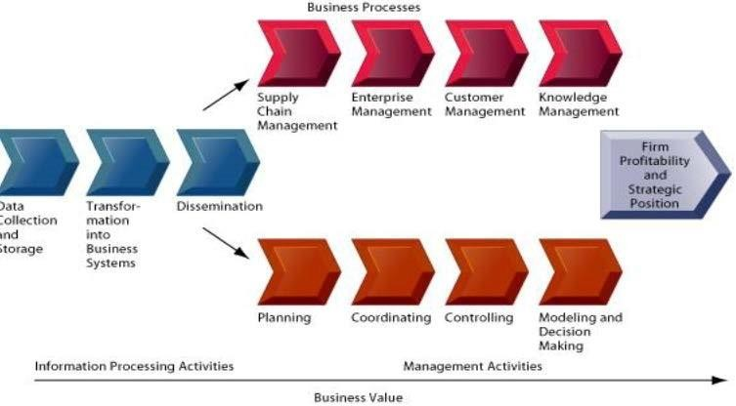
A business Perspective on Information System
Fig. the business information value chain
From a business perspective Information System are part of a value adding activities for acquiring, transforming and distributing information that managers can use to improve decision making, enhance organizational performance and ultimately increase firm profitability and strategic position.

Integrating text with technology: New opportunities for learning
See: www.prenhall.com/laudon

organization
IS
Management
Technology

Fig: Information System is more than Computers

Using Information System effectively requires an understanding of the organization, management and IT shaping the systems. All information systems can be described as organizational and management solutions to challenges posed by the environment that will help create value for the firm.

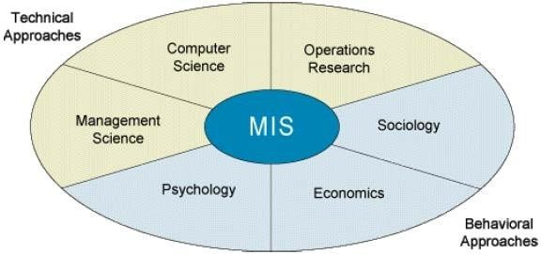
Contemporary Approach to Information System
Fig: Contemporary Approach to Information System

Technical Approach
- It emphasis mathematically based models to study Information System, as well as the physical technology and formal capabilities of these systems.
- The disciplines that contribute to technical approach are computer science, management science and operation research.
- Computer science is concerned with establishing theories of computability, methods of computation and methods of efficient data storage and access.
- Management science emphasis the development of models for decision making and management practices.

- Operations research focuses on mathematical techniques for optimizing selected parameters of organization such as transportation, inventory control and transaction cost.

Behavioral Approach
- It is concern with behavioral issues that arise in the development and long term maintenance of information system.
- Issues such as strategic business integration design, implementation, utilization and management cannot be explored usefully with the models used in technical approach.
- Other behavioral contribute system with an eye toward how group and organizations shape the development of the system and also how systems affect individuals groups and organizations.
- Psychologist study information system with an interest in how human decision makers perceive and use formal information.
- Economist study information system with an interest in what impact systems have on control and cost structures within the firm and within markets.
- Behavioral approach does not ignore technology. Indeed information system technology is often the stimulus for a behavioral problem or issues.
- Focus of behavioral approach is generally not on technical solutions. Instead, it concentrates on attitudes, management and organizational policy and behavioral. The Challenges of Information System
- The Strategic Business Challenge
- The Globalization Challenge
- The Information Architecture and Infrastructure Challenge
- The Information System Investment Challenge
- The Responsibility and Control Challenge

The Strategic Business Challenge
  - Realizing the digital firm:- how can business use IT to become competitive, effective and digitally enabled?
  - Creating a digital firm and obtaining benefits is a long and difficult journey for most organization.
  - Despite heavy information technology, investment organizations are not realizing significant business value from their system, nor are they becoming digitally enabled.

The Globalization Challenge
  - How can firms understand the business and system requirements of global economic environment?

The Information Architecture and Infrastructure Challenge
  - How can organizations develop an information architecture and information technology infrastructure that can support their goals when business conditions and technologies are changing so rapidly?

The Information System Investment Challenge
  - How can organization determine the business value of information system?

The Responsibility and Control Challenge
  - How can organizations ensure that their information systems are used in as ethically and socially and responsible manner?
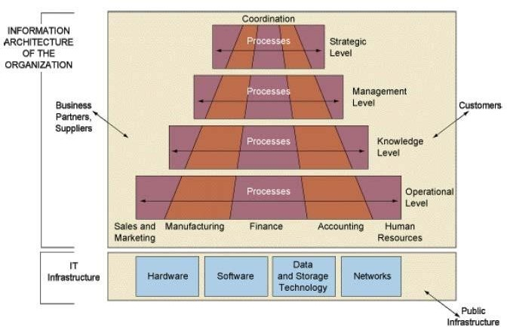
Fig: IT Infrastructure and IS Architecture

Chapter 2

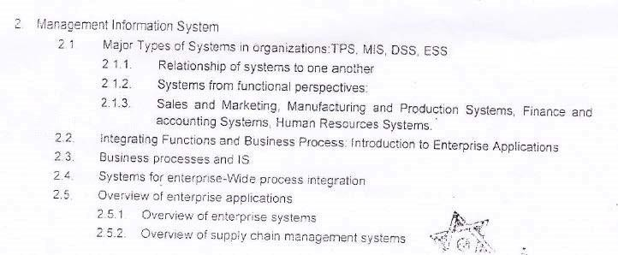
Management Information System

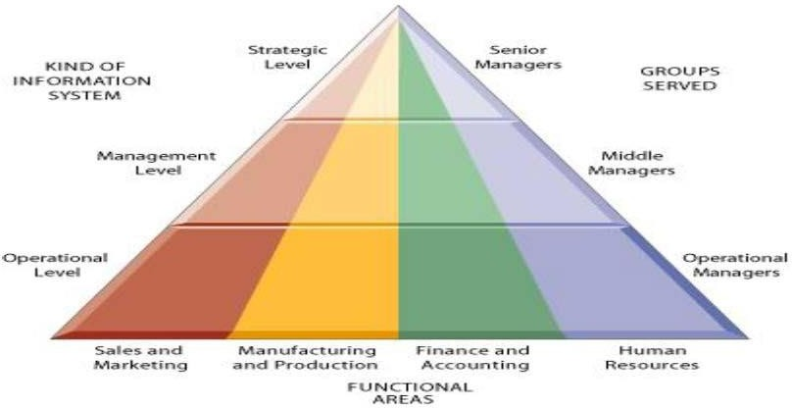
Fig: Types of Information System

Organizations can be divided into strategic, management, knowledge and operational levels and into five major functional areas- sales and marketing, manufacturing, finance, accounting, and human resource. Information system serves each of these levels and functions.

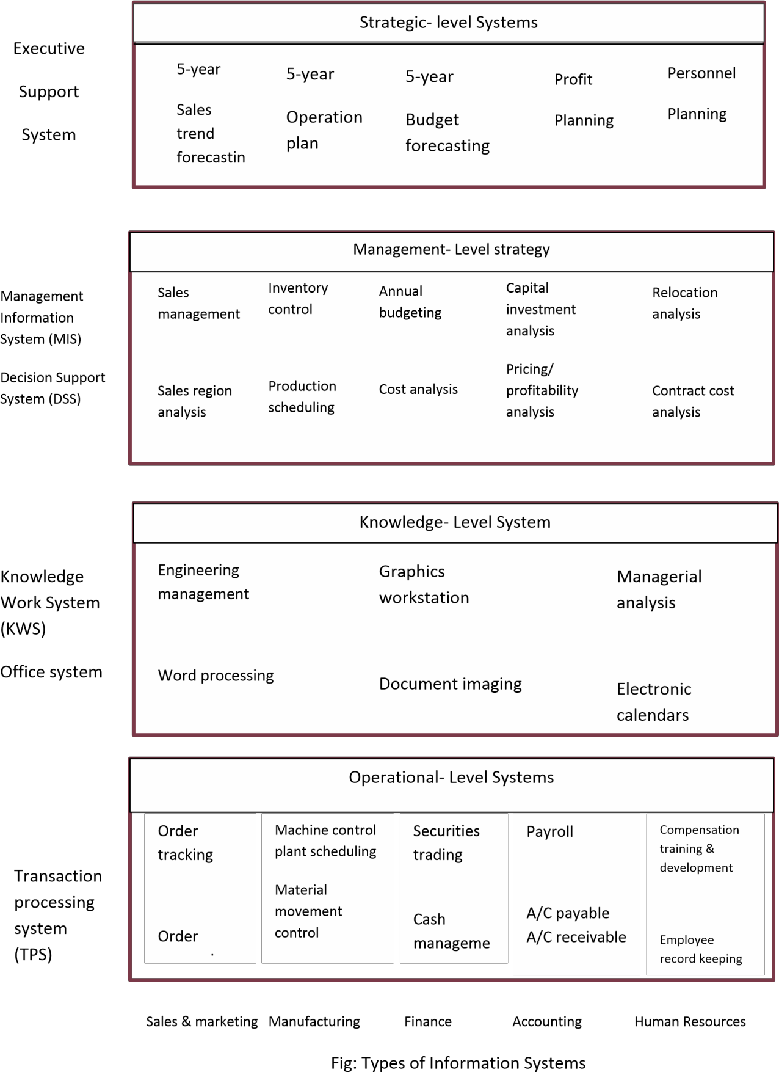

Relationship of systems to one another

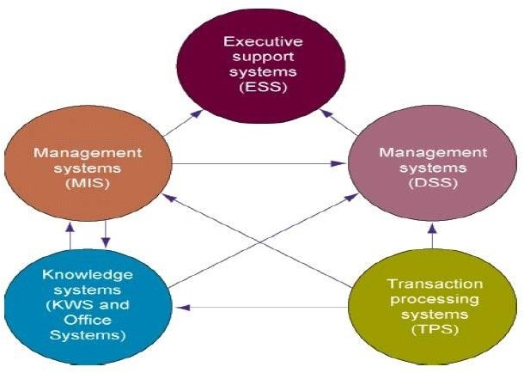
Fig: Interrelationships among systems

The various types of systems in the organization have interdependencies. TPS are a major producer of information that is required by the other systems which, in turn, produce information for other systems. These different types of systems are only loosely coupled in most organizations.

Types of Information system
- TPS (Transaction Processing System): TPS are the basic business systems that serve the operational level of the organization. A TPS is a computerized system that performs and records the daily routine transactions necessary to conduct business. Examples are sales order entry, hotel reservation system, payroll, employee record keeping, etc.
Managers need TPS to monitor the status of internal operations and firm’s relations with external environment. TPS are also measure producers of information for the other type of system.

- KWS (Knowledge Work System) and Office Systems: KWS and office systems serve the information needs at the knowledge level of organization. Knowledge work system aid knowledge workers whereas office systems primarily aid data workers. Knowledge workers are people who hold formal university degrees and who are often members of recognized profession such as engineers, doctors, lawyers, scientists, etc. Their jobs consist primarily of creating new information and knowledge. Data workers typically have less formal advanced educational degrees and tend to process rather than create

information. They consist primarily of secretaries, book-keepers, filing clerks or managers whose jobs are principally to use and manipulate information.

MIS
It is the Information system at the management level of an organization that serve the functions of planning, controlling and decision making by providing routine summary and exception reports.
MIS serve the management level of organization as stated above with online access to the organization’s current performance and historical records. Typically they are oriented almost exclusively to internal, not environmental or external events. MIS depend on TPS for their data. It summarize and report on the company’s basic operations. MIS usually serve managers interest in weekly, monthly and yearly results not day to day activities.

DSS (Decision Support System)
It is the information system at the organizations management level that combines data and sophisticated analytical models or data analysis tools to support semi-structured and unstructured decision making.
DSS use internal information from TPS and MIS; they often bring in information from external sources such as current stock prices or product prices of competitors. DSS have more analytical power then other systems. It is an interactive system in which user can change assumptions, ask new questions and include new data.

ESS (Executive Support System)
It is the information system at the organizations strategic level designed to address unstructured decision making through advanced graphic and communication. ESS is designed to incorporate data about external events such as new tan laws and competitors. They filter, compares and track critical data, emphasizing the reduction of time and effort required to obtain information useful to executive. ESS employs the most advanced graphic software and can deliver graphs and data from many sources immediately to a senior executive’s office or to a board room.

According to functions or behavior IS can be divided into following types:-
  - Sales and Marketing System
  - Manufacturing and Production Systems
  - Finance and Accounting Systems
  - Human Resources Systems

Sales and Marketing System
The sale and marketing function is responsible for selling the organization’s products or services. Marketing is concerned with identifying the customers for the firm’s products or services, determine what they need or want, planning and developing products and services to meet their needs, and advertising and

promoting these products and services. Sales are concerned with contacting customers, selling the products and services, taking orders and following up on sales. Sales and marketing information systems support these activities (example)
System | Description | Organization level
Order processing | Enter, process and track orders. | Operational Level
Market Analysis | Identify customers & markets using data on demographics, markets consumer behavior & trends. | Knowledge level
Pricing analysis | Determine prices for products & services. | Management level
Sales trend forecasting | Prepare 5-year sales forecast | Strategic level

- Manufacturing and Production Systems
The manufacturing and production function is responsible for actually producing the firm’s goods and services. Manufacturing and production activities deal with the planning, development, and maintenance of production facilities; the establishment of production goals; the acquisition, storage, and availability of production materials; and the scheduling of equipment, facilities, materials, and labor required to fashion finished products. Manufacturing and Production information systems support these activities (example)
System | Description | Organization level
Machine control | Control the action of machines & equipment | Operational Level
Computer aided design (CAD) | Design new products using the computer | Knowledge level
Production planning | Decide when and how many products should be produced | Management level
Facilities location | Decide where to locate new production facilities | Strategic level

Finance and Accounting Systems
The finance function is responsible for managing the firm’s financial assets, such as cash, stocks, bonds, and other investments, in order to maximize the return on these financial assets. The finance function is also in charge of managing the capitalization of the firm. In order to determine whether the firm is getting the best return on its investments, the finance function must obtain a considerable amount of information from sources external to the firm.
The accounting function is responsible for maintaining and managing the firm’s financial records-receipts, depreciation, payroll to account for the flow of funds

in a firm. Finance and accounting share related problems such as how to keep track of a firm’s financial assets and fund flows. Financial and accounting information system keep of the firm’s financial assets and fund flows.

System | Description | Organization level
Account receivable | Track money owned the  firm | Operational Level
Portfolio Analysis | Design the firms portfolio of  investments | Knowledge level
Budgeting | Prepare short term budgets | Management level
Profit planning | Plan long term profits | Strategic level

Human Resources Systems
The human resource function is responsible for attracting, developing, and maintaining the firm’s workforce. Human resources information systems support activities such as identifying potential employees, maintaining complete records on existing employees, and creating programs to develop employees’ talents and skills.
Strategic-level human resources system identify the employee requirements (skills, educational level, types of positions, number of positions, and cost) for meeting the firm’s long term business plans.

System | Description | Organization level
Training & Development | Track employee training, skills &  performance appraisals | Operational Level
Career pathing | Design career paths for employees | Knowledge level
Compensation analysis | Monitor the range & distribution of  employee wages, salary & benefits. | Management level
Human resource planning | Plan the long term labor force needs  of the organization. | Strategic level

Enterprise Application (System)
(See book)
Fig traditional view of system
In most organizations, separate systems built over a long period of time support discrete processes and discrete business function.
Integrating Functions and Business Progresses: Enterprise Systems and Industrial
Network

Functional Area | Business process

Manufacturing and production | - Assembling product  - Checking quality  - Producing bills of materials
Sales and marketing | - Identifying customers  - Creating customer awareness ➢ Selling
Finance & accounting | - Paying creditors  - Creating financial statements  - Managing cash accounts
Human resources | - Hiring employees  - Evaluating performance  - Enrolling employees in benefits plans

Cross-Functional Business Processes:
- Transcend boundary between sales, marketing, manufacturing, and research and development
- Group employees from different functional specialties to a complete piece of work

Example: Order Fulfillment Process
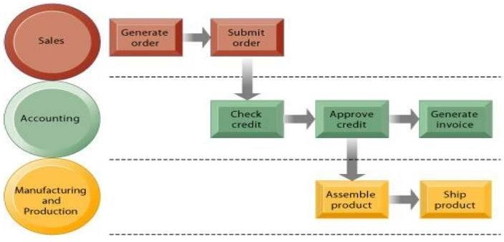
Fig: The order fulfillment process
Generating and fulfilling an order is a multistep process involving activities performed by the sales, manufacturing and production, and accounting functions.

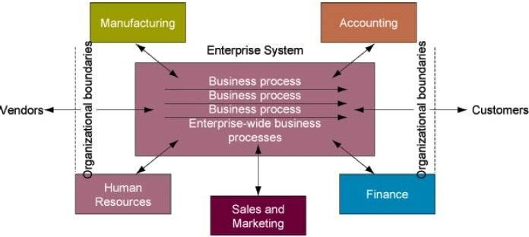
Fig: Enterprise systems

Enterprise systems can integrate the key business processes of an entire firm into a single software system that allows information to flow seamlessly throughout the organization. These systems may include transactions with customers and vendors. These systems focus primarily on the internal processes but may include transactions with customers and vendors.
Enterprise system provides a technology platforms where organization can integrated and coordinate their major internal business processes. They address the problem of organizational inefficiencies created by isolated islands of information, business processes and technology. A large organization typically has many different kind of information systems that support different functions, organizational levels and business processes. Most of these systems are built around different functions; business units and business processes that do not talk to each other. Managers might have a hard time assembling the data they need for a comprehensive, overall picture of the organizations operations.
Enterprise systems, also known as Enterprise Resource Planning (ERP) systems solve the above mentioned problem by providing a single information system for organizationwide coordination of key business processes.
The enterprise system collects data from various key business and stores the data in a a single comprehensive data repository where they can be used by other parts of business. Managers emerge with more precise and timely information for coordinating the daily operations of the business and firm-wide view of business processes and information flows.

Benefits of Enterprise system? See yourself consult book Challenges of enterprise system? See yourself consult book

Supply Chain Management System (SCM)

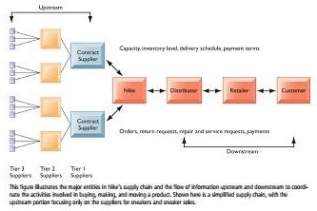

The above figure illustrates the major entities in the supply chain and the flow of the information upstream and downstream to coordinate the activities involved in buying, making and moving products. Suppliers transform raw materials into intermediate products or components and then manufacturers turn them into finished products. The products are shipped to distribution centers and from there to retailers and customers. The supply chain is a network of organizations and business processes for procuring materials, transforming raw materials into intermediate and finished products and distributing the finished products to customers. The supply chain includes reverse logistics in which returned items flow in the reverse direction from the buyers back to the seller. The upstream portion of supply chain includes the organizations suppliers and their suppliers and the processes for managing relationship with them. The downstream portion consists of the organization and processes for distributing and delivering products to their final customers.

Unit 3

Organizations and Information System

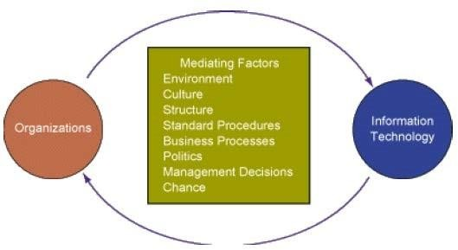
Fig Relationship between an organization & IT

Information systems and organizations influence one another. Information systems must be aligned with the organization to provide information that important groups within the organization need. At the same time the organization must be aware of and be open influences of information systems in order to benefit from new technologies.
The interaction between IT and organizations is very complex and is influence by a great many mediating factors including organizations structure, standard operating procedure, politics, culture, surrounding environment and management decisions.

What is an Organization?
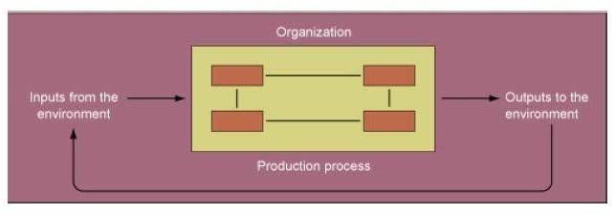
Fig: technical Microeconomic definition of organization.

An organization is a stable, formal, social structure that takes resources from the environment and processes them to produce outputs. This technical definition focuses on three elements of an organization. Capital and labor are primary production factors provided by the environment. The organization (the firm) transforms these inputs into products and services in a production function. The products and services are consumed by environment in ……………..for supply inputs. An organization is more stable then an informal group in terms of longevity and routines. Organizations are formal legal entities with internal rules

and procedures that must abide by laws. Organizations are also social structures because they are a collection of social elements.
Structure
•
•
•
•
Hierarchy
Division of Labor Rules, procedures
Business processes
Environmental Resource
•
•
•
•
•
Process
Rights/obligations Privilege/responsibilities Values
Norms
People
Environmental Outputs

Fig: The behavioral view of organization

A more realistic behavioral definition of an organization is that is a collection of rights, privilege, obligations and responsibilities that are delicately balanced over a period of time through conflict resolution. In this behavioral view of firm, people who work in organizations develop ways of working; they gain attachments to existing relationship; and they make arrangements and subordinates and superior about how work will be done, how much work will be done and under what condition.

How does these definitions of organization relate to Information System Technology???
  - A technical view of organizations encourages us to focus on the way inputs are combined into outputs when technology changes are introduced into the company. The firm is seen as infinitely malleable with capital and labor substituting for each other quite easily. But the more realistic behavioral definition of an organization suggest that building new information systems or building old ones involves more than a technical rearrangement of machines or workers- that some information system that change the organizational balance of rights, privilege, obligations, responsibilities and feelings that have been established over a long period of time.

Common features of organization

- Clear division of labor
- Hierarchy
- Explicit rules and procedures
- Impartial judgments
- Technical qualification for position
- Maximum organization efficiency

According to Max Weber, all modern bureaucracies have a clear cut division of labor and specialization. Organizations arrange specialist in a hierarchy of authority in which everyone is accountable to someone and authority in which everyone is accountable to someone and authority is limited to specific actions. Authority and actions are further limited by abstract rules and procedures (Standard Operating Procedures (SOPs)) that are interpreted and applied to specific cases. These rules create a system of impartial and universal decision making; everyone is treated equally. Organizations try to hire and promote employees on the basis of technical qualifications and professionalism (not personal connection). The organization is devoted to the principle of efficiency: maximizing output using limited inputs.
In addition to Weber’s common feature all organizations develop SOP, organizational politics and organizational culture.

Unique Features of Organizations

- Organizational Type
- Environments
- Goals
- Power
- Constituencies
- Function
- Leadership
- Tasks
- Technology
- Business Processes

Organizational Type

- Entrepreneurial type ->small start-up business
- Machine bureaucracy -> middle size manufacturing firms
- Divisionalized bureaucracy -> combination of multiple machine bureaucracies
- Professional bureaucracy -> intellectual firms (eg: schools, college, etc) 5. Adhocracy -> consulting firms
Organizations have different shapes or structure for many other reasons. They differ in their ultimate goals and the types of power used to achieve them some organizations have utilitarian goals (business), others have normative goods (universities, religious groups). Organizations also serve different groups or have different constituencies, some primarily benefiting their members, others benefiting clients, stock holders or the public. The nature of leadership differs greatly from one to another organization. Some organizations may more democratic than other. Another way organization differs is by task they perform and the technology they use. Some organization perform primarily routine task that could be reduced to formal use that require little judgment. How information system impact organizations and business firm

Economic Impact
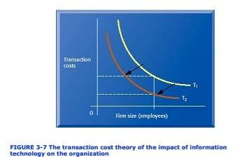

Fig 1: The transaction cost theory of the Impact of IT on
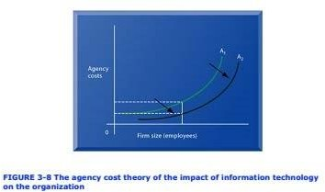
organization
Fig 2: The agency cost theory of the impact of IT on Organization
From the economic point of view information system technology can be freely substituted for capital and labor. IT should result in a decline in the number of middle managers and clerical workers as IT substitutes for their labor. IT also helps firms contract in size because it can reduce transaction cost. According to transaction cost theory, firms and individuals seek to economize on transaction cost, much as they do on production cost. Using markets is expensive because of costs such as locating and communicating with distance suppliers, buying insurance, obtaining information on products and so on. IT especially by the use of networks can help firms lower the cost of market participation (transaction cost). Information systems make it possible for companies such as CISCO systems and Dell Computer to outsource their production to contract manufacturers such as Flextronics instead of making their product themselves. In the above fig1 transaction cost decreases by the help of IT enable organization then traditional organization.
Information technology also can reduce internal management cost. According to agency theory the firm can be viewed as a “ nexus of contracts” among self- interested individuals who must be supervised and managed.
IT by reducing the cost of acquiring and analyzing information, permits organizations to reduce agency cost because it becomes easier for manager to observe a greater number of employees. IT also expand the power and space of

small organizations by allowing them to perform coordinating activities such as processing orders or keep track of inventory with very few clerks and managers.

Behavioral Impact
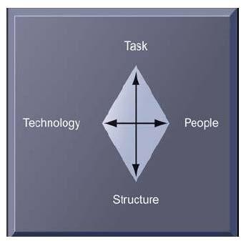
Information technology may encourage task force network organization in which groups of professional come together face to face electronically for short period of time to accomplish a specific task; once the task is compiled the individuals joint other task forces. More firms may operate as virtual organizations where work no longer is tied to geographical location. Virtual organization use networks to link people, assets, and ideas. Another behavioral approach views information systems as the outcome of political competition between organizational groups for influence over the organizations policies, procedures, and resources. Information systems potentially change an organizations structure, culture, politics, and work.
Fig: organizational resistance + changes that should be accomplished simultaneously to change organization

The Internet and Organizations

-Internet (WWW) have an important impact on the relationships between firms and external entities and even on the organizational business process inside a firm.
-It increases the accessibility, storage and distribution of information and knowledge for organizations.
-The most important thing internet is capable of dramatically lowering transaction and agency cost in many organizations.
-Websites saves millions of dollars in distribution costs.
-Instant price and product information can be updated via internet.
-Some businesses are totally dependent on internet.

The role of manager’s in organizations Classical Model
- Classical Function of Managers: (According to Henri Fayol and others in 1920’s)
Planning, organizing, coordinating, deciding, controlling
- These are just formal managerial function and are unsatisfactory as a description of what managers actually do when they plan, decide things and control work.

- Behavioral model state that the actual behavior of managers appears to be less systematic, more informal, less reflective, more reactive, less well- organized and much more frivolous (assuming, silly) than the classical model.
- According to behavioral model there are mainly three roles played by managers
  - Interpersonal Roles
  - Informational Roles
  - Decisional Roles Interpersonal Roles
Role | Behavior | Support System
Figurehead | Interpersonal | None
Leader | Interpersonal | None
Liaison | Interpersonal | Electronic  communication

Informational Roles
Role | Behavior | Support System
Never Centre | Information Process | MIS, ESS
Disseminator | Information Process | Mail, Office systems
Spokesperson | Information Process | Office & Professional  system, work stations
Decisional Roles
Role | Behavior | Support System
Entrepreneur | Decision Making | None
Distribution Handler | Decision Making | None
Resource Allocation | Decision Making | DSS
Negotiator | Decision Making | None

Managers and Decision Making Types of Decision

- Structured
- Semi Structured
- Unstructured

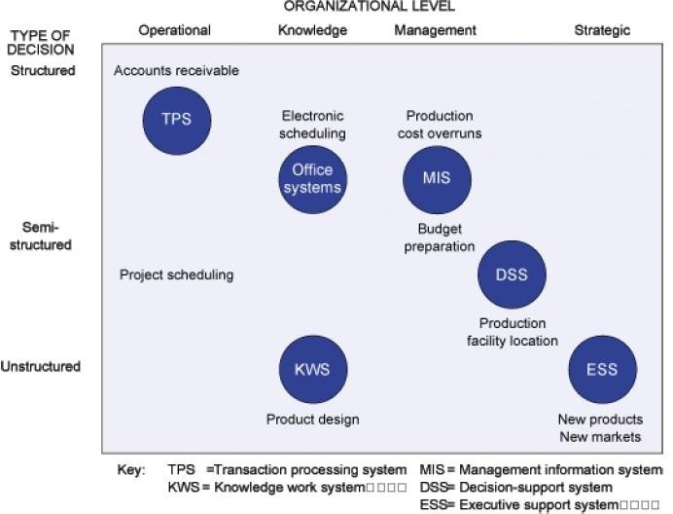
Fig: stages of Decision Making
Stages of decision making

Is there a problem?
Intelligence
What are the alternatives?
Design

Which should you choose?
Choice

Is this choice working?
Implementation

Models of Decision Making
- Rational Models
An individual’s management identifies goals, ranks all possible alternatives actions and chooses the alternatives that contributes most to those goals.
- Organizational Model
Considers the structural and political characteristics of an organization.
- Bureaucratic Model
Whatever organization do is the result of routines and existing business process developed over years of active use.
- Political Model
What an organization does is a key result of political bargains struck among key leaders and interest groups.

Strategic Information System (SIS)
It change the goals, operations, products, services or environmental relationships of organizations to help them gain and edge over competitors. Systems that have these effects may even change the business of organizations. Strategic information system can be used at all organizations. Strategic information system can be used at all organizational levels and it is not restricted to strategic level system. There are a number of information systems operating at different level of strategy the business, the firm and the industry level
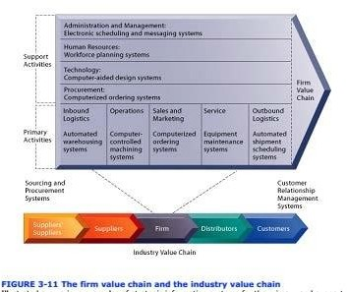
Fig: the firm value chain & industry value chain

The Value Web

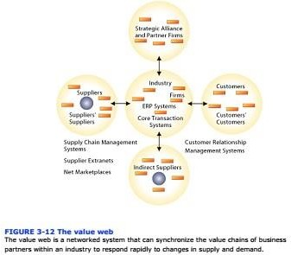

Fig: The Value Web

The value web is a networked business ecosystem that can synchronize the value changes of business partners within an industry to respond to changes in supply & demand.

Industrial Strategies
- Information partnership
- Competitive Forces Model
- Network Economics

Competitive Forces Model
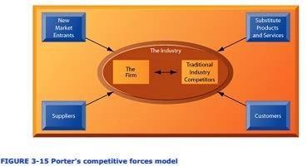
Fig 1: Porter’s Competitive Forces Model

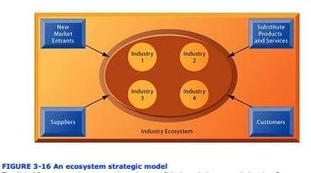

Fig 2: New Competitive Forces Model

Competitive force model is a model is used to describe the interaction of external influences, specially threads and opportunities that affect an organizations strategy and ability to compete.
In fig 1 it shows Porter’s competitive force model. There are various forces that effect on organizations ability to compete and therefore greatly influence firms business strategy. There are threats from new market entrance and from substitute products and services. Customers and suppliers develop bargaining power. Traditional competitors constantly adopt their strategies to maintain their market positioning.
In fig 2 shows the new competitive force model. The digital firm era requires a more dynamic view of the boundaries between firms, customers and suppliers with competition occurring among industry sets.

Information Systems and Business strategies
Business can use strategic information systems to gain an edge over competitors. Such systems change organizations goal, business processes, products, services or environmental relationships driving them into firms of behaviour.
Information systems can be used to support strategy at the business, firm and industry level. At the business level of strstegy, information systems can be used to help firms become the low cost procedures, differentiate products and services or serve new markets. Value chain analysis is useful at the business level to highlight specific activities in the business where information systems are most like to have a strategic impact.
At the firm level, information systems can be used to achieve new efficiencies or to enhance services can by trying together the operations of different business unit so that they can function as a whole or promoting the sharing of knowledge across business units.
At the industry level, systems can promote competitive advantage by facilitating cooperation with other firms in the industry, creating consortiums or communities for sharing information, exchanging transactions or coordinating activities. The competitive force model, information partnership and network economies are useful concepts for identifying strategic opportunities for systems at industry level.

Literature
1. Management Information System (Full Notes). https://www.slideshare.net/HarishChand5/management-information-system- full-notes,

