Clean Air for Everyone 🌬️
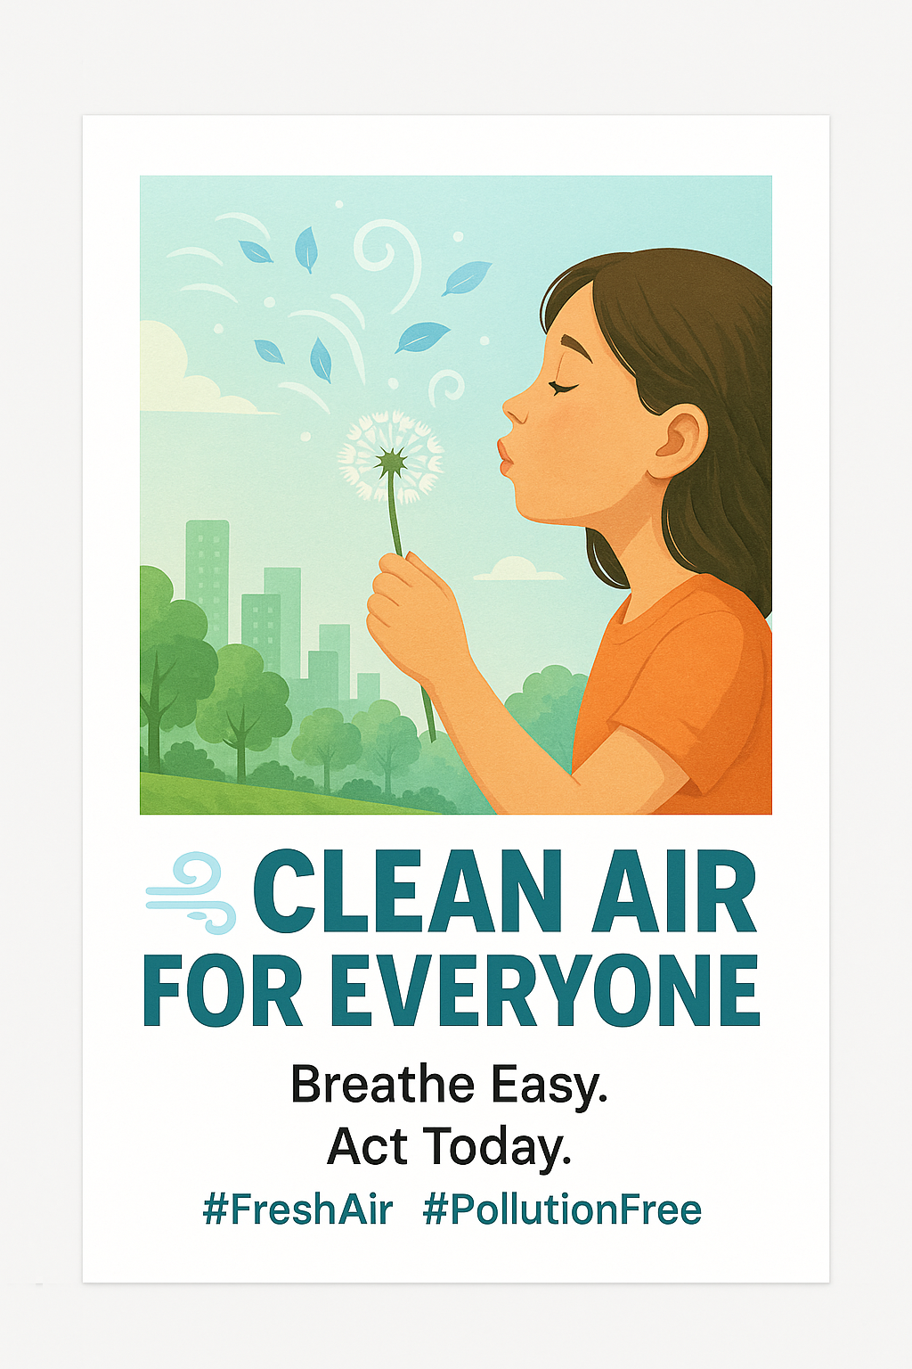
Breathe Easy. Act Today.
#FreshAir #PollutionFree

