Case. Strategic IT plan for Enterprise architecture management

The Strategic Planning Process

Overview
Ukrainian University (UU) made a strategic decision to re-organize the information organization, separating the Chief Information Officer (CIO) responsibilities. During the intervening months, the institution took part in a national search for a new CIO. The search process was successful and the new CIO started with the university August 1, 2016. This position reports to the Rector of the university.
As a result of this re-organization, the newly formed Office of Information Technology is now focused on assessing roles and responsibilities for ensuring the division aligns with the strategic direction, mission, vision, and goals of Ukrainian University. A significant step in making this happen is development and implementation of a formal strategic planning process for information technology support on campus resulting in a plan that details the steps necessary in creating a comprehensive information technology support infrastructure that aligns with the institution.

Purpose
The purpose of this strategic planning process is to determine how best to align information technology support with the mission, vision, values of the institution and its various departments and to help develop a strategic plan for providing organized and user-friendly information technology support to campus. The following illustration shows the elements of UU's institutional information technology strategic planning process:

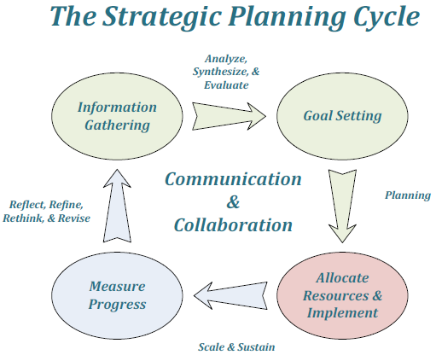
The Strategic Planning Cycle

Information Gathering

The information gathering for the strategic planning process took place in Spring, 2017. There were 3 ways in which this information was gathered:
- Web Survey
- Interviews with key individuals (Rector; - Vice-Rectors; - Deans; - Chairs)
- Focus group discussions (Executive Directors, Leadership o Teaching and Learning Leadership o Key Student Services and Administrative Directors)
- Key Constituent Groups (Staff Organization; Student Organization, Campus Leadership, Office of Information Technology Staff)

Analyze, Synthesize, and Evaluate
Analysis of the data collected during the various information-gathering processes took place throughout Summer, 2008. Many significant issues and areas of focus came from this effort. This information was shared with campus late in September 2008 to ensure that issues were captured and to provide verification of campus needs. As this plan is developed, each stage will be shared with campus through a wiki. Feedback and input will be requested at each stage of development to insure that the final product will reflect the true needs of campus and align with the institution’s mission, vision, and goals.

Setting Goals
From the initial charge set forth to the CIO from the University Rector, in August 2016 through the Information Gathering and Analysis Stages of the Strategic Planning Process, four primary goals have emerged for Information Technology Support at Ukrainian University:

GOAL 1: Provide an Effective, Efficient, and Flexible Information Technology Organization
The Office of Information Technology will become a comprehensive, collaborative leader for innovation, implementation, maintenance, and support of information technology systems across the institution.

Strategy 1: Re-engineer the Organization - The Office of Information Technology
Led by the Chief Information Officer (CIO), the Office of Information Technology (IT) reorganization will provide comprehensive, campus-wide IT leadership, implementation, maintenance, and support provided through three units (Information Systems, Customer Support Systems, and Academic Systems) with centralized support provided through the CIO’s office.
This structure will afford Ukrainian University with a comprehensive IT strategy for implementation and support that will provide a cost-effective, efficient IT infrastructure aligning with the institution’s mission, vision, and goals:

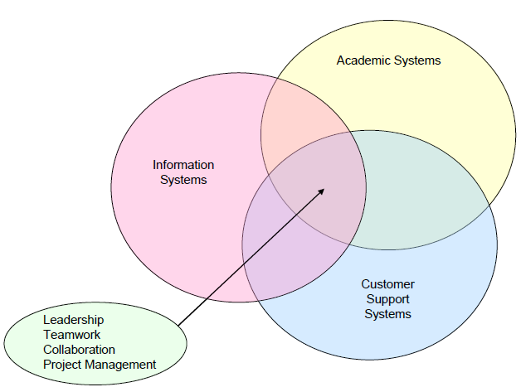

Action 1: Develop the Information Systems Unit
The Information Systems unit is responsible for the recommendation, implementation, development, administration, and maintenance of enterprise-level applications for the institution. This unit is led by the Director of Information Systems. The Director provides supervision and leadership for a unit consisting of programmers, system administrators, and database programmers.
The areas of responsibility for the Director of Information Systems include (but are not limited to):
Implementation and maintenance of Administrative Applications
Enterprise Resource Planning – Banner
Ancillary Administrative Systems
Workflow
Database and Reporting – Operational Data Store
Reporting – Oracle Discoverer, Crystal Reports, etc.
Implementation and maintenance of Communications Applications – Microsoft Exchange (Email & Calendaring)
Implementation and maintenance of Web Applications
Implementation and maintenance of Other Proprietary Applications
Application Development

Action 2: Develop the Customer Support Systems Unit
The Customer Support Systems unit is responsible for the recommendation, implementation, development, administration, and maintenance of all information technology-related customer support for the institution. This unit is led by the Director of Customer Support Systems. The Director provides supervision and leadership for a unit consisting of technical support staff, system administrators, and network administrators. The areas of responsibility for the Director of Customer Support Systems include (but are not limited to):
- Development and management of a comprehensive, campus-wide information technology support structure
- Development and management of a comprehensive help desk
- Implementation and maintenance of all student, staff, and faculty desktop computers & peripherals
- Implementation and maintenance of information technology in campus facilities
- Implementation and maintenance of information technology infrastructure
- Enterprise computer server
- Technology support for events
- Implementation, maintenance, and support for video conferencing

Action 3: Develop the Academic Systems Unit
The Academic Systems unit will be responsible for the recommendation, implementation, development, administration, and maintenance of all academic-specific systems for the institution. This unit will be led by the Director of Academic Systems. The Director will provide supervision and leadership for a unit consisting of technical support staff, system administrators, technical trainers, graphic designers, and course development specialists.
The areas of responsibility for the Director of Academic Systems include (but are not limited to):
Implementation and maintenance of academic-specific information technology systems:
Course management systems – Blackboard, Moodle, Sakai, etc.
Audio and video distribution systems – Helix, iPod University, etc.
Audience response systems – Clickers, etc.
Testing software
Implementation and maintenance of and support for technology-related training (in partnership with
Teaching & Learning Center (TLC) and Human Resources)
Implementation and maintenance of and support of faculty for technology-enhanced curriculum design and development
Management and support for the Student Technology
Leadership and participation in faculty and student academic advisory committees and workgroups
Lead faculty in research of new academic technologies

Action 4: Develop the Central Support Unit
The Office of the CIO provides central leadership and support for the Information Systems, Customer Support Systems, Academic Systems units, and other institutional IT. Central support includes (but is not limited to):
Project management led by the Manager of Project Management:
Central planning for all large-scale projects
Implementation, maintenance, and training for project and collaborative application tools
Supervision and leadership for large-scale project lead personnel
Administrative support is led by the Manager of Support Systems, who is responsible for: Budget management, Purchasing and bill payment, Software/systems licensing and maintenance
Back office support
Reception
Event planning
Central scheduling
File organization and archive
Supervision and leadership of
support team personnel

Planning
Multiple strategies have been identified for attaining the goals identified above. Within each of these strategies, individual action plans will be developed. The remainder of this document will detail these strategies and action plans.

Assignment 1.
1) To define strategies and actions for development of goals 2, 3 and 4 using questionnaire for key stakeholders of Ukrainian Universities:

Goal 2: Provide a Robust Technology Infrastructure
The Office of Information Technology will develop and maintain a robust infrastructure that will ensure the security, availability, and integrity of the institution’s information technology systems and networks.

Goal 3: Provide Professional Customer Service and Support
The Office of Information Technology will develop a highly-effective, comprehensive, professional customer support structure.

Goal 4: Provide Leadership in Developing and Maintaining a Strong Institutional Data and Reporting Environment
The Office of Information Technology will work with institutional leaders in developing a secure and available system for creation, collection, recording, maintenance, and reporting of institutional data.

