Remember to use Present Simple talking about permanent situations, habits and regular actions.
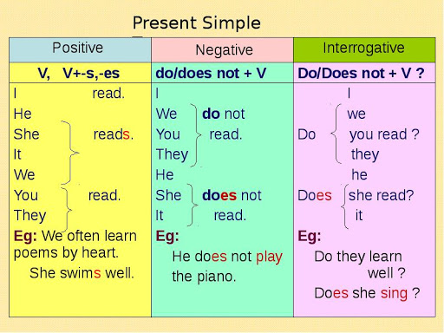
Present Simple
We use the Present Simple tense to talk about:

- things that happen regularly;
- permanent situations;
- habits and routines;
- laws of nature;
- timetables and programmes.

